Text Editor using Java

Requirements:

1. A Text area
2. Menu bar

Implementation Details:

1. Creating GUI using Java swings:

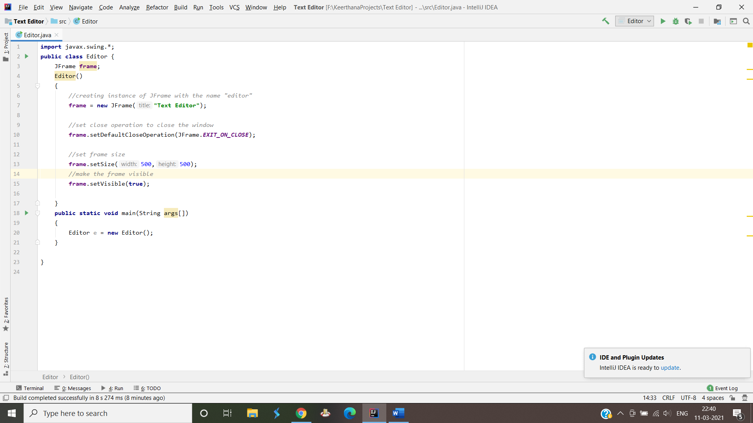

The output of the following code looks like follows:

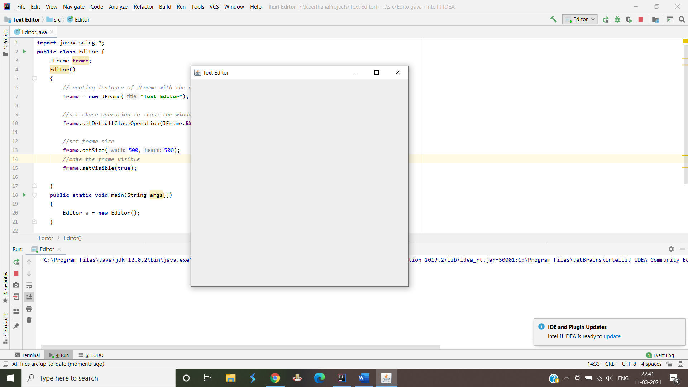

1. Creating Menu Bar:

After we have built the screen, we need to create a menu bar with options.We use JMenuBar class to do this.JMenuBar is an implementation of the menu bar.It can contain one or more JMenu objects.

When the JMenu objects are selected they display a popup showing one or more JMenuItems.

Part of Swings class.

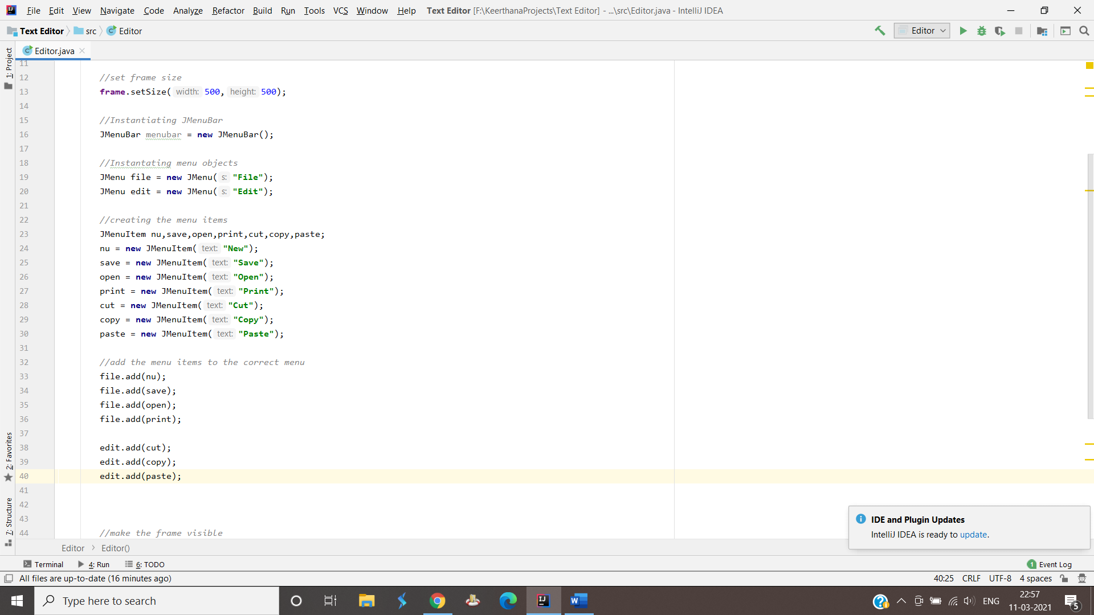

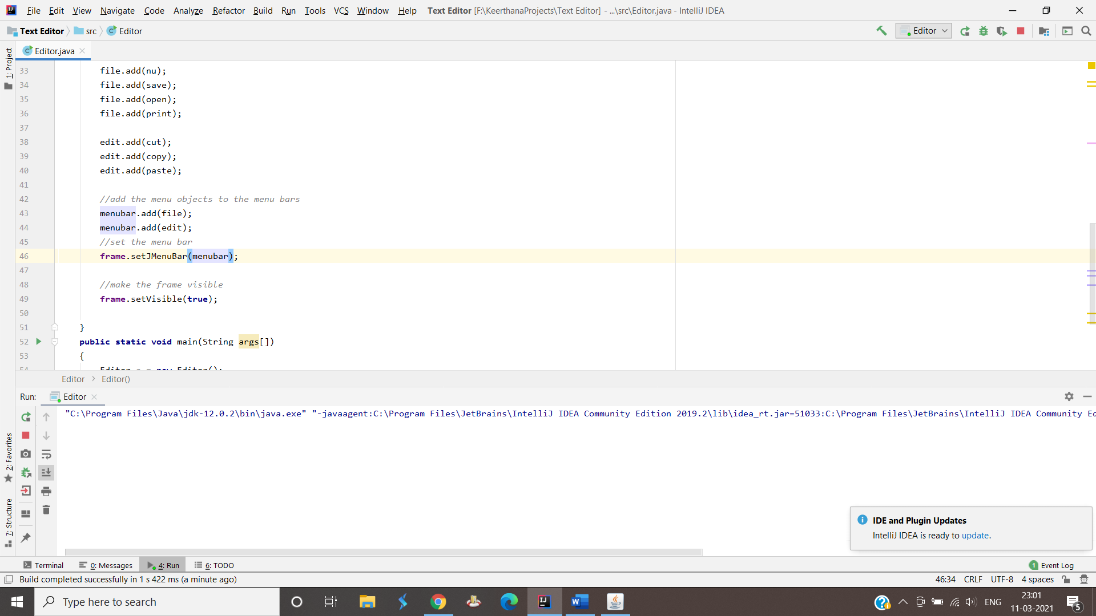

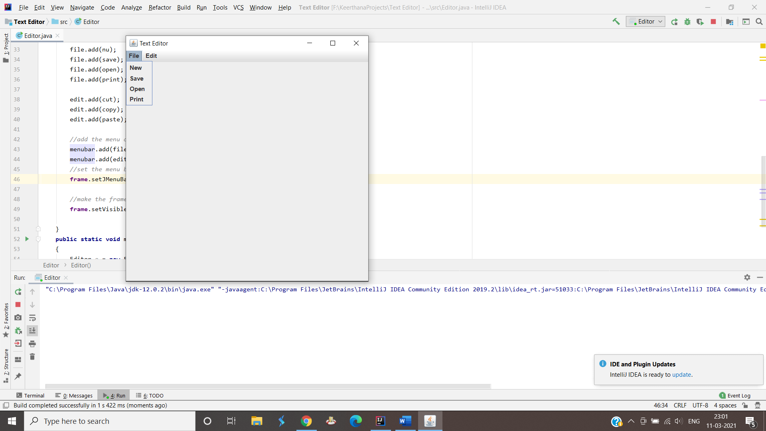

1. JPanel:

We need a container to hold our components in the main screen.We use JPanel for this.

Part of Swings class.

Flow layout is used to arrange our components in a line one after the other.

1. JTextarea:

Allows user to input multiline text.

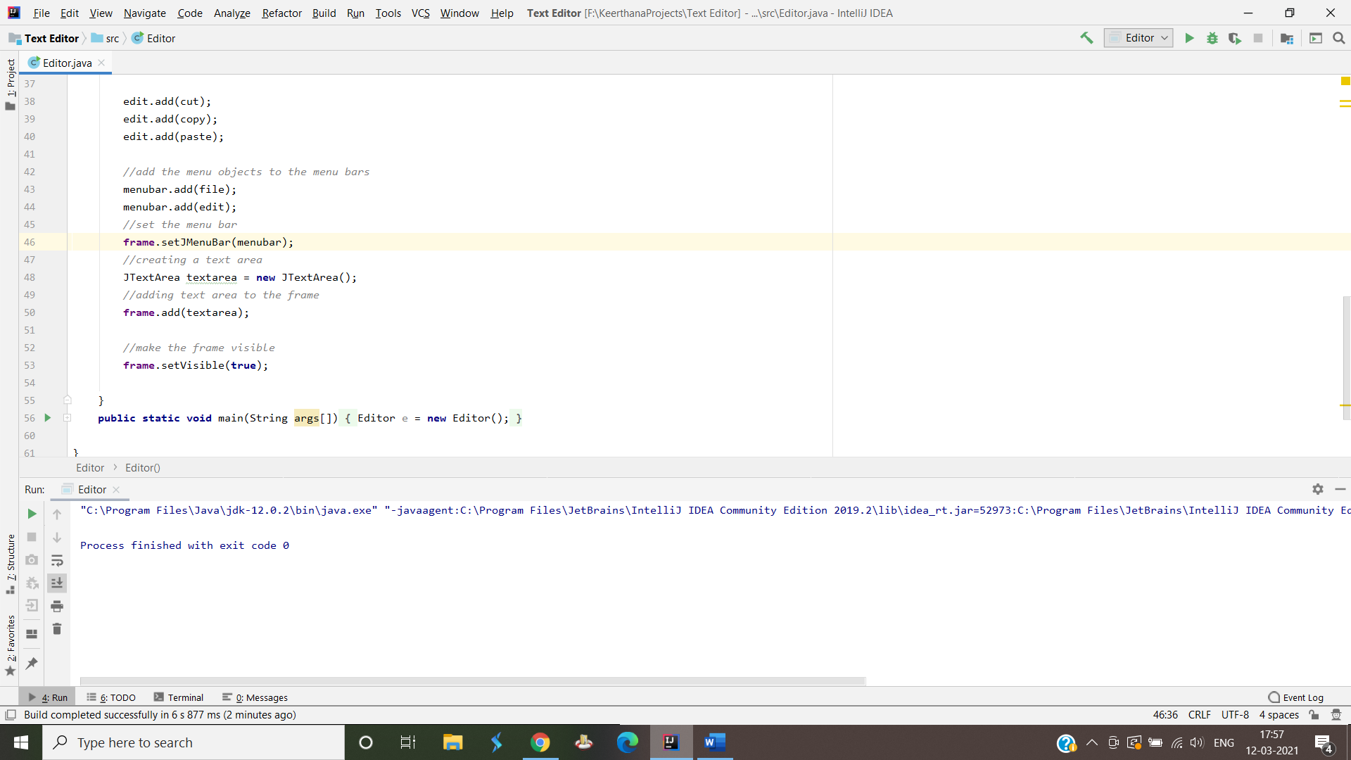

1. Adding Action Listeners:

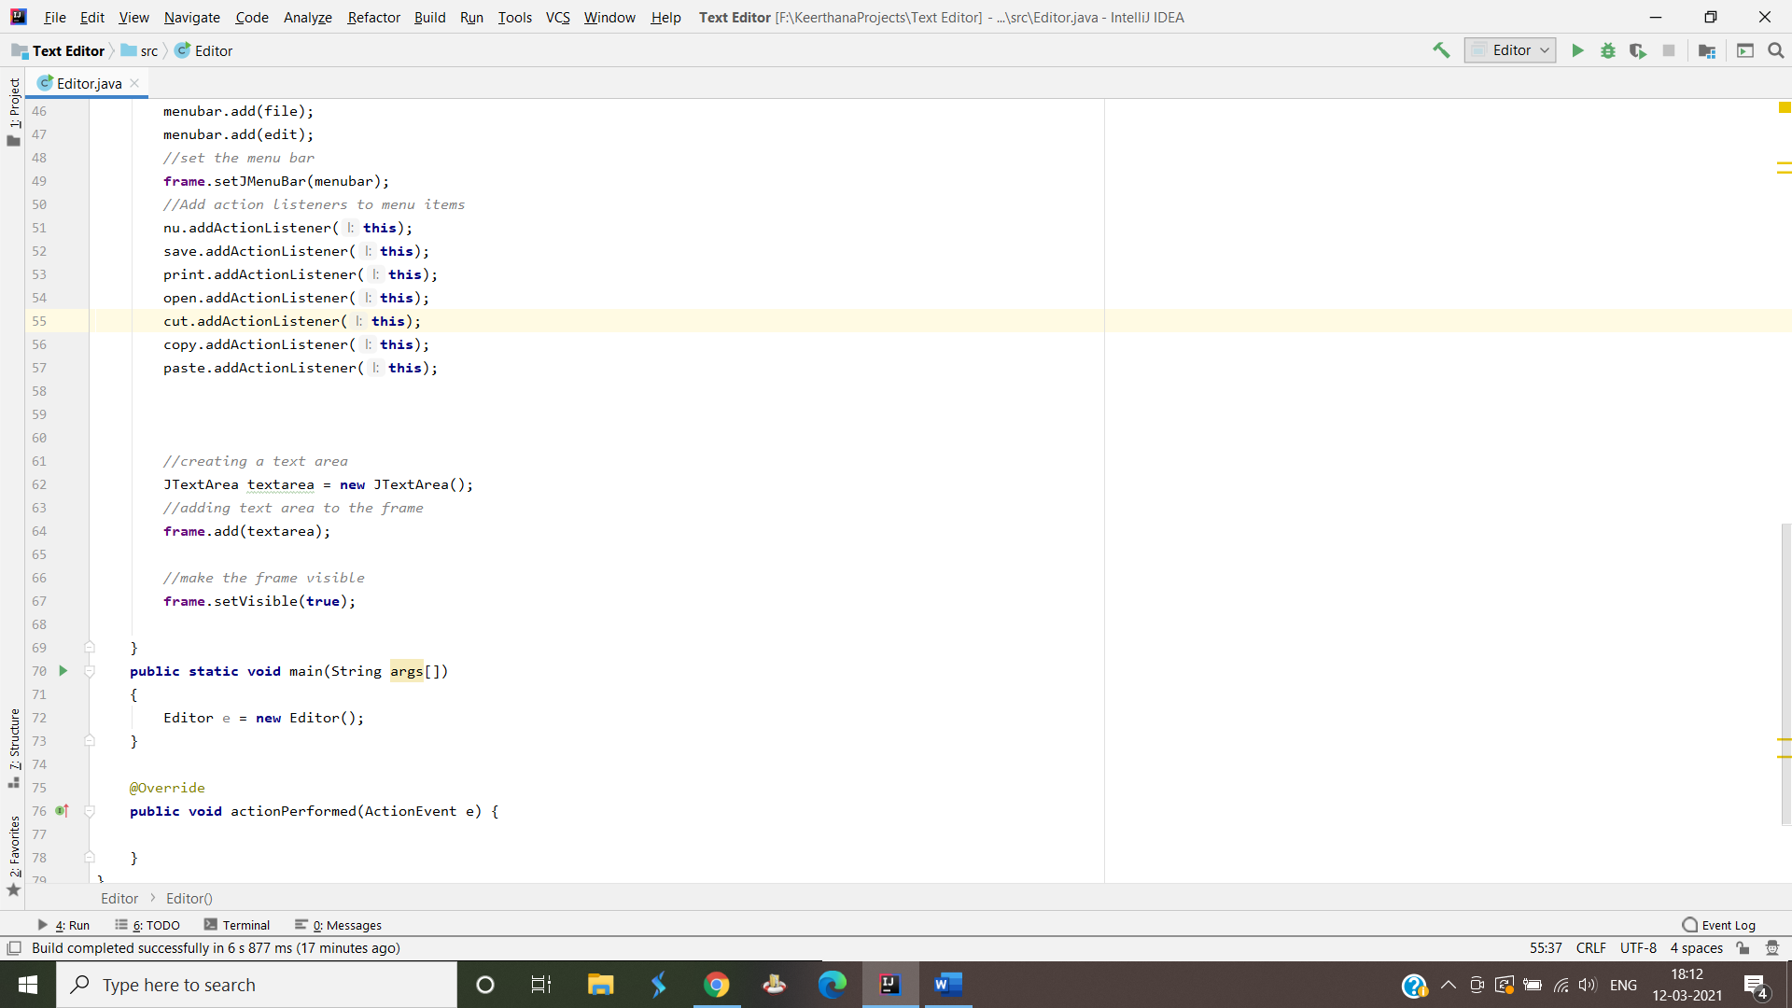

* We need to now focus on how to save the file , i.e., if we want to save whatever we wrote in the textarea as a textfile.
* File Writer is useful for creating a file by writing characters into it.They are meant to write characters.
* File Writer creates the output file if not present already.



 